If you want to test out the reset password, you will have to follow some steps from here

1. Open __init__.py on your text editor

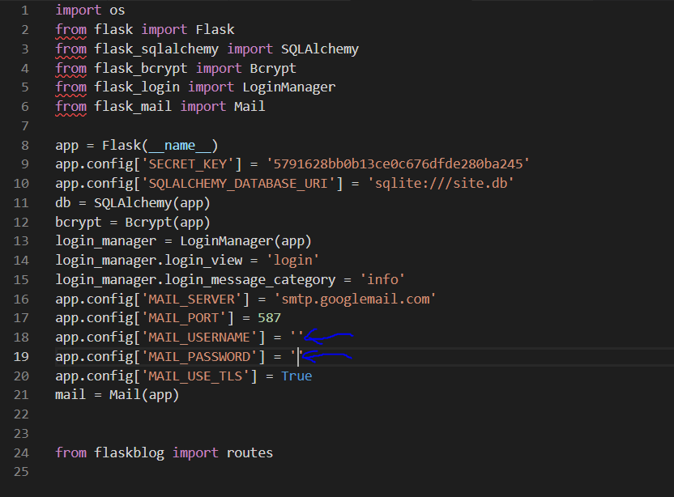

1. Put a valid email address on the 18th line and the password of that email address on the 19th line
2. Now open route.py and go to the line 179 and put the same email as the one you put inside __init__.py

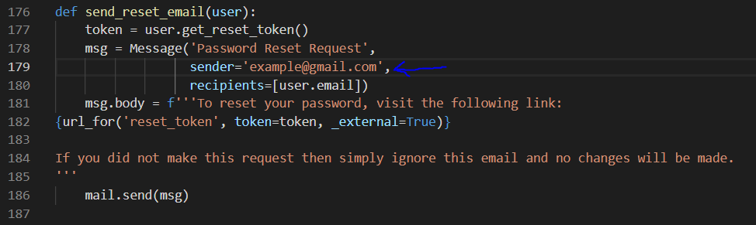

And now you are good to go !

The reason that I make those instruction it was because I had my own personal email for testing if it works.